Line of Business: User Interface

Exercise 1: Investigation

1. Open config.xml. What are the names of the two configuration parameters that control whether the "Choose by Coverage" or "Choose by Coverage Type" menus are displayed for a given line of business?
2. Which loss type in the base application is not listed in the default settings for these two parameters? (If necessary, view the LossType typelist in the data dictionary or in Studio.)
3. Modify config.xml so that "Choose by Coverage" and "Choose by Coverage Type" are reconfigured as illustrated below.

**NOTE:** You must restart ClaimCenter to deploy config.xml changes.

The effect of these changes is to allow auto exposures to be created only using "Choose By Coverage" and to allow general liability exposures to be created using "Choose by Coverage Type." Other coverage types are not affected. Thus:

* For auto claims (such as claim 235-53-365870), exposures are created only by coverage as shown below:

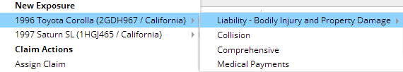

* For property claims (such as claim 426-24-366070), exposures are created either by Coverage Type or by Coverage as shown below:

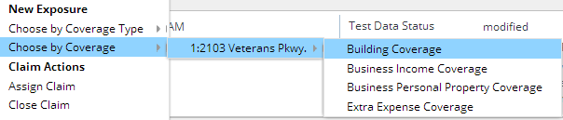

* For general liability claims (such as 345-50-123321), exposures are created only by using Choose by Coverage Type as shown below: 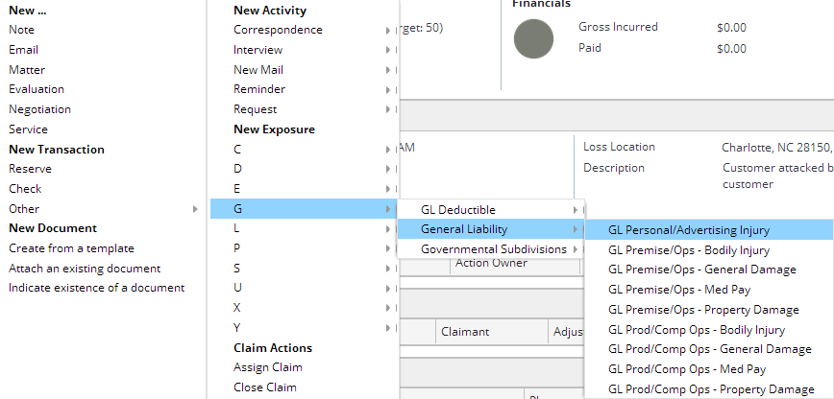

**Exercise 2: Configuration**

In the previous lab, you configured ClaimCenter to include a new Erosion coverage for Homeowner's policies. In this lab, you will configure ClaimCenter to meet the following customer requirement from Acme Insurance.

**Requirement:** Eroded Property Damage for Erosion Coverage

The business analysts at Acme Insurance have determined that the type of information needed for an erosion exposure is significantly different from that of other exposures with the **Dwelling** exposure type. Therefore, Erosion coverage needs its own exposure type called **Eroded Dwelling Damage**.

You may find it helpful to view a homeowner's claim in implementing the changes called for in this exercise. See claim #426-24-366170.

**IMPORTANT:** Before you begin configuration, read the notes provided by the Claim Center implementation team as listed below.

4. Create a new exposure type called "Eroded Dwelling Damage" (internal code "ErodedDwellingDamage"). Modify the line of business model so that this exposure type is the only exposure type associated with the Erosion coverage type. Your new exposure should be tied to the DwellingIncident.

1. When you update the data model, create a new CoverageSubType and retire the ERO-DWEL one from previously.

5. Create a Panel to be used for creating new erosion exposures on an existing claim. For now, the new Panel can be identical to the one used for Property Damage/Dwelling. Locate the NewExposure modal Panel used for Property Damage/Dwelling in the Project View, make a copy of the PCF and paste in the duplicate, being sure its file name contains the new exposure type "ErodedDwellingDamage" as its suffix.

The new Panel should have a label at the top which reads:   
  
"Remind the insured that pending legislation may limit erosion coverage in coastal regions."

1. To create a label for an entire panel, use a "Verbatim" widget placed on the including PanelRef.

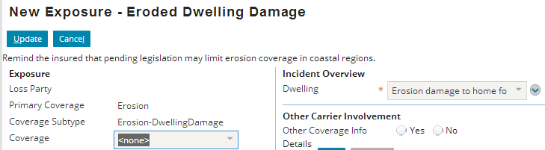

1. There are some modal elements in your duplicated Panel which do not yet support your new mode of ErodedDwellingDamage. Modify the appropriate modal inputset to support 2 modes by adding ErodedDwellingDamage. Use the Project View to execute the "Change PCF Mode..." menu option.

6. Create a Panel to be used for viewing exposures on an existing claim that uses the "Eroded Dwelling Damage" exposure type. Do this by repeating the steps you followed for creating Panels to support New exposures that use the "Eroded Dwelling Damage" exposure type.   
  
*NOTE: Normally, you would create detail views for the New Claim Wizard and FNOL snapshot. To keep the lab at an appropriate length, these detail views do not need to be created for this exercise.* 

For now, the new Panel can be identical to the one used for Property Damage/Dwelling, except for a label at the top which reads:

"Remind the insured that new legislation expected next year may limit erosion coverage in coastal regions."

7. It is necessary to update the initializeIncident() function in the ExposureUI.gsx module to include a case for your new exposure type. Treat it the same as you do the Dwelling exposure type.

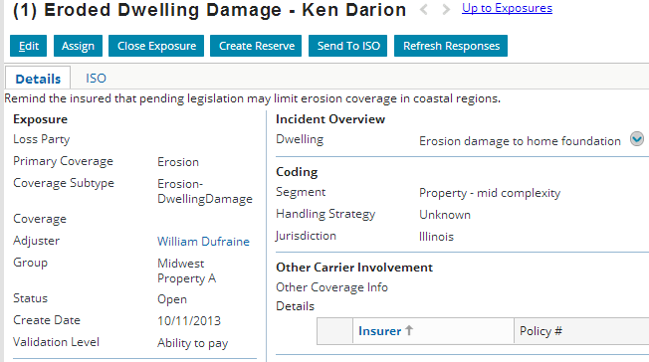

**Test Cases**

When you have completed your configuration, run the following test cases:

8. Log on as William Dufraine Using a homeowner's claim, such as claim 426-24-366170, create an erosion exposure. You should now see your new form and new exposure type. Then, save the exposure and verify you can view it in detail after it has been saved.